Intro to NFT Deployment
Crypto collectibles compatible with the ERC-721 standard have become very popular since the launch of Cryptokitties and have moved forward towards mass adoption in recent months. This guide will cover creating and deploying our very own ERC-721 (NFT) using the 0xcert/ethereum-erc721 smart contract library.

What is a Non-Fungible Token?
Fungible means to be the same or interchangeable. For example, Ethereum tokens, all the members of a particular token class, have the same value. The same can be said of Cardano tokens. Fungible tokens are interchangeable 1:1.

With this in mind, NFTs are unique; each one is different. Every single token has unique characteristics and values. The types of things that can be NFTs are collectible cards, artworks, airplane tickets, etc. They are all clearly distinguishable from one another and are not interchangeable. Think of Non-Fungible Tokens (NFTs) as rare collectibles; each has unique characteristics, unusual attributes, and most times, its metadata.

Use cases of Non-Fungible Tokens (NFTs):
- Digital art (or physical art): Art pieces are the most popular use cases of NFTs. Digital art auctions were the first application of NFTs and continue to grow.
- Gaming: Providing in-game purchases and collectibles of games.
- Real estate: Tokenizing properties and smart contracts and carry buying and selling.
- Finance: Financial instruments like loans, futures, and other responsibilities.
- Software titles: Software licenses to ensure anti-piracy and privacy.
- Concert tickets/Sports match tickets: To ensure that no fraud happens in ticket selling and fans can have a single place to view past experiences.
- KYC compliance: Creating a token for a specific user’s KYC.

Some Explanation of the functions:
ERC20-like Functions:
- name: Used to define the token’s name, which other contracts and applications can identify.
- symbol: Used to define token’s shorthand name or symbol.
- totalSupply: This function is used to define the total number of tokens on the blockchain; the supply doesn’t have to be constant.
- balanceOf: Returns number of NFTs owned by an address.

Ownership Functions
- ownerOf: This function returns the address of the owner of a token. As each ERC-721 token is unique and non-fungible, they are represented on the blockchain by an ID. Other users, contracts, apps can use this ID to determine the owner of the token.
- approve: This function grants or approves another entity the permission to transfer tokens on the owner’s behalf.
- takeOwnership: This is an optional function that acts like a withdraw function since an outside party can call it to take tokens out of another user’s account. Therefore, takeOwnership can be used when a user has been approved to own a certain amount of tokens and wishes to withdraw said tokens from another user’s balance.
- transfer: This is another type of transfer function; it allows the owner to transfer the token to another user, just like cryptocurrencies.
- tokenOfOwnerByIndex: This is an optional but recommended function. Each owner can own more than one NFT at the same time. Its unique ID identifies every NFT, and eventually, it can become difficult to keep track of IDs. So the contract stores these IDs in an array and the tokenOfOwnerByIndex function lets us retrieve this information from the array.
Metadata Function
- tokenMetadata: This optional feature is an interface that lets us discover a token’s metadata or a link to its data.
Events
- Transfer: This event is fired when the ownership of the token changes from one individual to another. It emits the information on which account transferred the token, which account received the token, and which token (by ID) was transferred.
- Approve: This event is fired when a user approves another user to take ownership of the token, i.e., it is fired whenever approve function is executed. It emits the information on which account currently owns the token, which account is approved to take ownership of the token in the future, and which token (by ID) is approved to have its ownership transferred.

Faucet | https://faucet.ropsten.be/
Meta-Mask | https://metamask.io/
Ensure you are logged into meta-mask first and connected to the Ropsten Faucet

https://ipfs.io/#install
Smart Contract:
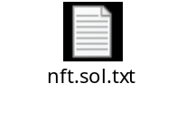

Getting test ETH

Adding Files to IPFS
Step 1: Creating IPFS repo.
$ ipfs init
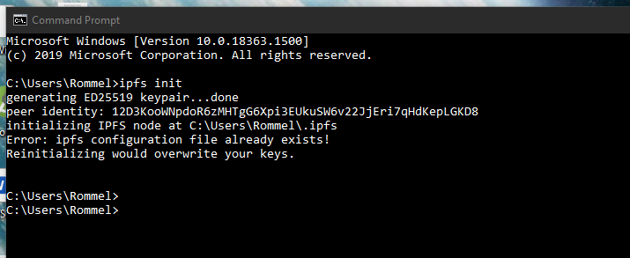

Step 2: Starting the IPFS daemon.
$ ipfs daemon
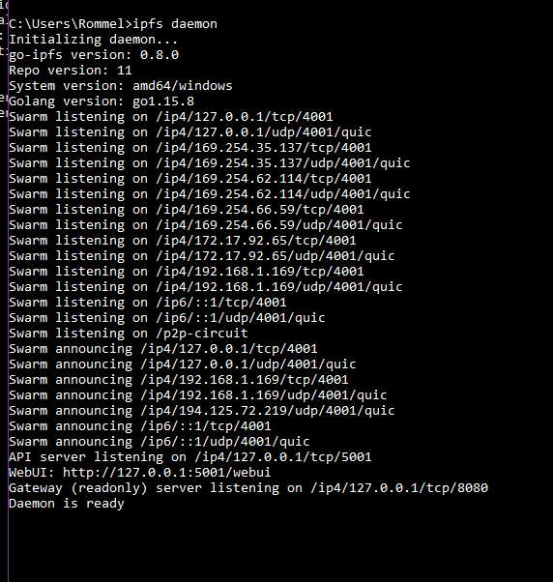
Step 3: Adding an image to IPFS
$ ipfs add art.png
Copy the hash starting from Qm and add the “https://ipfs.io/ipfs/” prefix to it; it must look something like this https://ipfs.io/ipfs/QmQEVVLJUR1WLN15S49rzDJsSP7za9DxeqpUzWuG4aondg
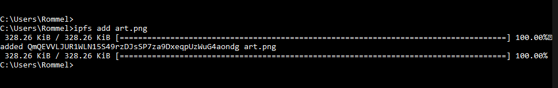
https://ipfs.io/ipfs/QmQEVVLJUR1WLN15S49rzDJsSP7za9DxeqpUzWuG4aondg

Step 4: Adding JSON file to IPFS
Create a JSON file nft.json and save it in the same directory as the image.
JSON file format:

{
"name": "NFT Art",
"description": "This image shows the true nature of NFT.",
"image": "https://ipfs.io/ipfs/QmQEVVLJUR1WLN15S49rzDJsSP7za9DxeqpUzWuG4aondg",
}

Now add the JSON file.
$ ipfs add nft.json

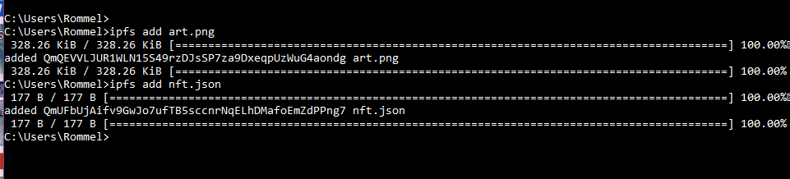

https://ipfs.io/ipfs/QmUFbUjAifv9GwJo7ufTB5sccnrNqELhDMafoEmZdPPng7

Copy the hash starting from Qm and add the “https://ipfs.io/ipfs/” prefix to it; it must look something like this https://ipfs.io/ipfs/QmUFbUjAifv9GwJo7ufTB5sccnrNqELhDMafoEmZdPPng7
Save this URL. We'll need this to mint our NFT.

Creating our own token.
For ease and security, we’ll use the 0xcert/ethereum-erc721 contract to create our NFT. With 0xcert/ethereum-erc721, we don’t need to write the whole ERC-721 interface. Instead, we can import the library contract and use its functions.

Example of importing the standard – The code for the smart contract is attached at the top of this document :
import "https://github.com/0xcert/ethereum-erc721/src/contracts/tokens/nf-token-metadata.sol";
import "https://github.com/0xcert/ethereum-erc721/src/contracts/ownership/ownable.sol";

Once Deployed in Remix
Add your Ropsten address in the _to the field.
Enter any Big number value in the _tokenid field - You can just put in 1 here.
Add URI of JSON file in the _uri field, which we obtained in the previous section.
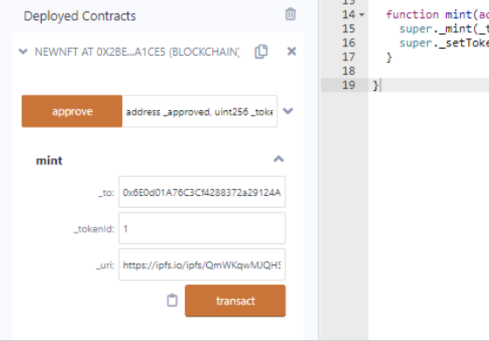

More on this :
https://github.com/0xcert/ethereum-erc721
https://en.wikipedia.org/wiki/Non-fungible_token
https://ipfs.io/#install
http://www.imponderablethings.com/2013/07/how-bitcoin-works-under-hood.html

